
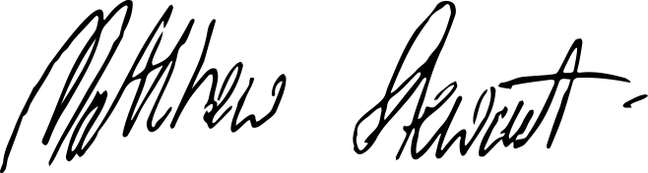


Certiﬁcate of Registration
This document certifies that the Management System of

Red Survey Limited
Unit 2 Goodwood Drive Sparkford Somerset BA22 7FQ
have been assessed and approved by Citation ISO Certification Limited to the following management systems, standards and guidelines:-

ISO 9001:2015
The scope of the Management System applies to the following:-

The supply, service, repair and hire of surveying instruments and allied ancillary equipment, cable locators and gas detectors

Original approval: 28/03/2025 Current certificate: 28/03/2026 Certificate expiry: 27/03/2029 Certificate number: 484242025

On behalf of Citation ISO Certification Limited.

Muspole Court, Muspole Street, Norwich, Norfolk, NR3 1DJ
Thiscertificate remainsvalid while the holder maintainstheir management system in accordance with the published Standard. To checkthe validity and status of this certificate please visit www.IRQAO.com or email ISOcertificates@citation.co.uk. This Certificate is the property of Citation ISO Certification Limited and must be returned in the event of cancellation.

